DareBoost

Dareboost is a tool for testing, analysis and monitoring of website’s quality and speed of access. Dareboost can be used through their online website or using an extension for chrome or firefox.

**FEATURES:**

* **Synthetic Monitoring:** Dareboost can monitor your pages within only a few seconds. This can be scheduled for automatic monitory may it be daily or hourly.
* **User Journey Monitoring:**
* **Website Analysis:** Dareboost can check and give out detailed info about your website from the performance of your website to the accessibility of it.
* **Website Speed Test:** This can simulate how many people can access your website simultaneously. This gives out detailed info for both the user and the technicalsides.

**WEBSITE STANDARDS:**

I have ran some test using dareboost. For every 1 hour I analyzed the website.

***WEBSITE SAMPLE:***

[***http://aboitizfoundation.org/***](http://aboitizfoundation.org/)



***WEBSITE TEST WITH DAREBOOST:***

***HOUR 1***

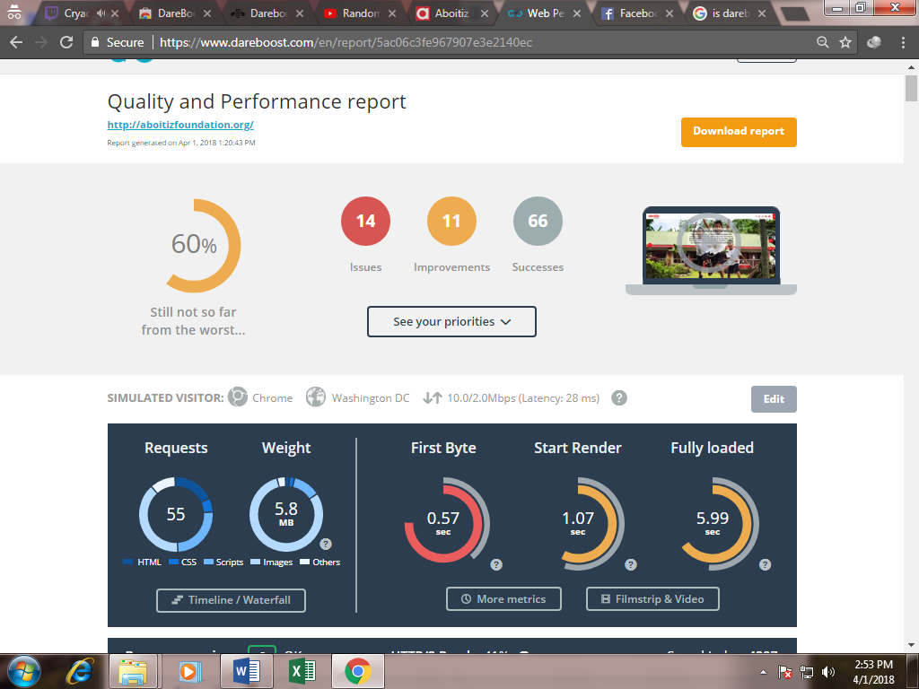

***HOUR 2:***

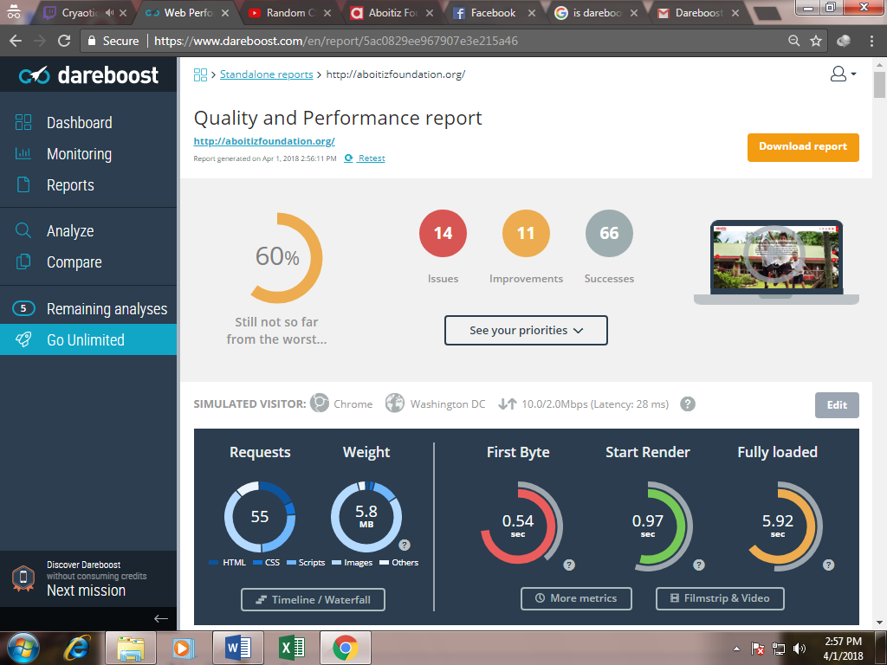

***STANDARDS:***

Dareboost Rates the website from security to accessibility with a score of 90 to 100 to be deemed as passing.

This standards includes but not limited to:

* Data amount – includes resources, file formats, redirects, cookies, requests, CSS, and compression
* Browser rendering – includes dependency of third party content, parsing of javaScript, Character sets, HTML response, execution of Scripts, client-server redirection, injection of scripts, use of import Stylesheets, Dom elements
* Quality – includes the use of gzip/deflate, Css selectors and properties, comments, Separation of html and stylesheets, overridden css, colors, extension of resources, IDs in codes, duplicates of CSS and the use of CSS selectors
* Security – Secured Connection, Content Security, cookies, links, integration of web
* SEO – the meta description, alt attributes, the use of Open Graph, number of links. Generally how you used your html tags and the elements in them
* JQuery – includes on how many Jquery you used and how fast it is. The use of DOM
* Cache Policy –includes requests from third partires, inline scripts and Headers (e.g Expires, Vary)
* Compliance – includes BOM (Byte order Mark), the use of obsolete tags, java Applets, the use of standard links, no use of Flash and Silverlight plugin, EOT format, Depracated attributes